

Project Interim Report

On

Geometric Shape Area Calculator (Using Core Java & OOP Concepts)
RU-100-01-00012
Object Oriented Programming with Java

SESSION: 2025-26

Submitted By Aditya Kumar RU-25-10098

Bachelor of Technology in Computer Science
Engineering in association with Google

Under the Guidance of Mr. Sivansh Metha

SCHOOL OF COMPUTER SCIENCE AND ENGINEERING RUNGTA INTERNATIONAL SKILLS UNIVERSITY
BHILAI, CG

(April 2026)

Abstract

This project focuses on the design and implementation of a Geometric Shape Area Calculator using Object-Oriented Programming (OOP) principles in Java. The primary goal of this project is to calculate the areas of different geometric shapes in a structured and reusable manner.

In traditional programming, calculations for different shapes are often handled separately, leading to repetitive and unorganized code. This project solves that problem by introducing abstraction through an interface called Shape, which defines a common method for area calculation. Different shapes like Circle and Square implement this interface and provide their own specific logic.

The system allows users to create objects of different shapes and compute their areas efficiently. This project demonstrates key OOP concepts such as abstraction, polymorphism, and method implementation. It provides a clean, scalable, and maintainable solution that can be extended to include more shapes in the future.

Introduction

Mathematics has always relied on formulas, but programming demands structure. This project bridges both worlds.

The Geometric Shape Area Calculator is designed using Java and follows core Object-Oriented Programming principles. Instead of writing separate functions for each shape, we define a common interface (Shape) that enforces a standard method calculateArea().

Each shape—like Circle and Square—implements this interface and provides its own formula. This ensures:

- Code reusability
- Clean structure
- Easy scalability

Features
- Uses interface-based abstraction
- Supports multiple shapes
- Easy to extend (Triangle, Rectangle, etc.)
- Demonstrates runtime polymorphism

Scope

This project is suitable for:
- Students learning OOP concepts
- Basic geometry calculations

It can be extended further by:
- Adding more shapes (Triangle, Rectangle, etc.)
- Integrating user input (Scanner)
- Connecting with a database
- Building a GUI-based application

System Requirements
Hardware
- Computer with minimum 4GB RAM

Software
- Java JDK
- IDE (VS Code / Eclipse / Edit Plus)

Methodology

The program follows a simple logical flow:

- Define a common interface (Shape) with a method calculateArea().
- Create different classes (Circle, Square) implementing this interface.
- Each class provides its own formula for area calculation.
- In the main method:
  - Objects of shapes are created
  - Area is calculated using polymorphism
- Output is displayed to the user
Think of it like a workshop:
Same tool (method), different craftsmen (classes), each doing their job their own way.

Flowchart
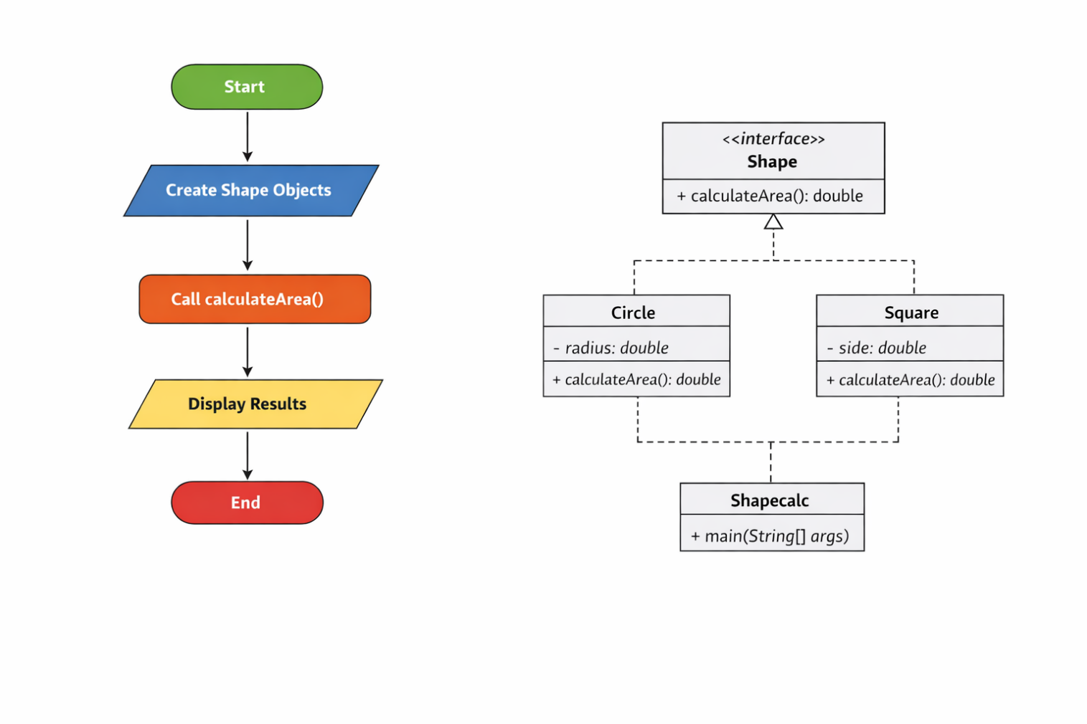
Class Diagram
Interface: Shape
- Method:
  - calculateArea()

Class: Circle
- Variables:
  - radius
- Methods:
  - calculateArea()

Class: Square
- Variables:
  - side
- Methods:
  - calculateArea()

Class: Shapecalc (Main Class)
- Methods:
  - main()

Implementation

• Shape Interface
Acts as a blueprint. It ensures every shape must implement calculateArea().

• Circle Class
Stores radius and calculates area using formula:
π × r²

• Square Class
Stores side length and calculates area using:
side × side

• Main Class (Shapecalc)
- Creates objects of Circle and Square
- Uses interface reference (polymorphism)
- Calls calculateArea() dynamically

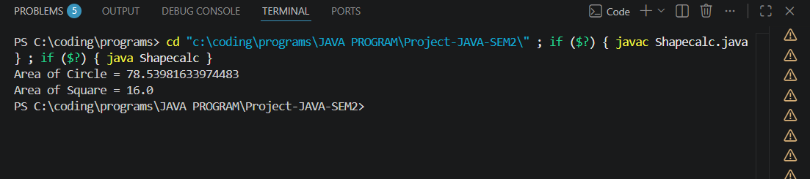

Future Enhancements
- Add more shapes (Triangle, Rectangle, Cylinder)
- Take user input using Scanner
- Build GUI using Java Swing / JavaFX
- Add unit conversion (cm², m², etc.)
- Integrate with database for storing results

Gantt Chart

Task | Duration
Planning & Design | 2hrs
Coding | 1hrs
Testing | 1hrs
Documentation | 2hrs

Importance

- Helps track progress
- Avoids last-minute rush
- Improves discipline in development

Conclusion
This project successfully demonstrates the power of Object-Oriented Programming. By using abstraction and polymorphism, we transformed simple mathematical formulas into a structured and scalable system.
It’s not just about calculating area—it’s about learning how to think like a programmer:
One interface, many forms, endless possibilities.

References Book Format:
[1] Author(s), *Book Title*, Edition. City: Publisher, Year.

Example:
[1] H. Schildt, *Java: The Complete Reference*, 11th ed. New York: McGraw-Hill, 2018.

Website Format:
[2] Author (if any), "Title of page," Website Name. [Online]. Available: URL

Example:
[2] Oracle, "Java Documentation," Oracle. [Online]. Available: https://docs.oracle.com

Conference Paper
Format:
[3] Author(s), "Paper title," in Proc. Conference Name, year, pp.
Example:
[3] S. Kumar, "AI in Education," in Proc. IEEE Conf. on AI, 2021, pp. 120-125.

Journal Article
Format:
[4] Author(s), "Title of paper," Journal Name, vol., no., pp., year.
Example:
[4] A. Sharma and R. Gupta, "Machine Learning Techniques," International Journal of AI, vol. 5,
no. 2, pp. 45-50, 2020.

